AI Camera 2.0 Basic Projects

Lesson 3: Color Block Tracking

Ages: 12 and up
Duration: 45 minutes

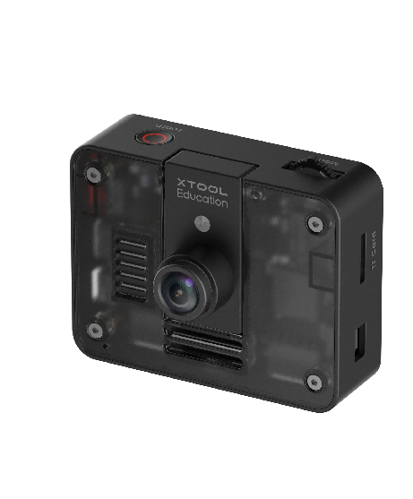

Objectives:

By the end of class, students will be able to:
- Understand the basic principles of color recognition in computer vision
- Master the use of the color recognition module and related parameters
- Use programming to achieve color recognition and robot tracking functions

Overview
This course guides students into the world of artificial intelligence visual perception by exploring how color recognition technology controls mBot2 robots. Students will learn how to use the AI Camera to recognize objects of different colors and program the robot to automatically track a specified color ball. The course emphasizes practice and innovation, encouraging students to design personalized color-responsive behaviors and enhancing their interest and understanding of computer vision applications.

Pre-lesson Checklist
For the teacher:
- Computer with mBlock installed and tested;
- Adequate number of mBot2 robots (fully charged);
- AI Cameras compatible with mBot2;
- CyberPi and connection cables;
- A yellow foam block;
For the students:
- Computer with mBlock installed and ready;
- mBot2 robot and AI camera set per group;
- CyberPi and connection cable;
- Red, green, and blue colored foam blocks;
- Reserved space for testing and experimentation;
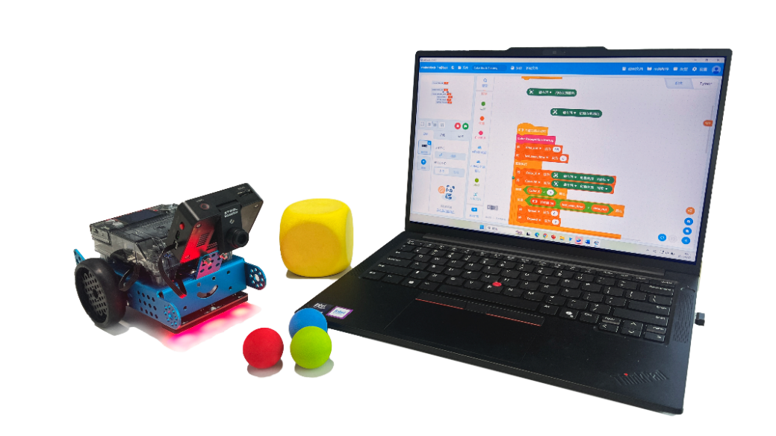

Agenda (45minutes)
Duration | Content
5 minutes | Section 1 - Introduction  - Demonstrate a pre-programmed mBot2 automatically tracking a yellow foam block;  - Prompt interaction: “How does the mBot2 'see' and track colors?”
10 minutes | Section 2 - Explore  - Understand the basic principles of color recognition in computer vision;
15 minutes | Section 3 - Create and practice  - Set up the color recognition environment and activate color recognition;  - Determine variables and program to achieve color tracking behavior;
10 minutes | Section 4 - Presentation  - Invite 2-3 groups to demonstrate their color tracking projects;  - Discuss the implementation methods and creative points of different groups;
5 minutes | Section 5 - Evaluate  - Review the challenges encountered and how they were resolved;  - Explore applications of color recognition technology in other scenarios;

Activities

Section 1 - Introduction
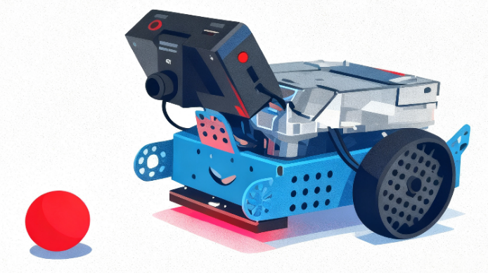
In this lesson, we will use the AI Camera as the "eyes" of the robot to learn how it recognizes colors. You will personally experience the complete process from color recognition to mechanical control: by writing a program, the AI Camera will identify a specific color foam block, calculate its position on the screen, and ultimately drive the mBot2 robot to move toward the block, achieving automatic tracking.

Section 2 - Explore
This section aims to clarify the fundamental principles of color recognition.
Learn the HSV Color Model
The AI Camera uses the HSV model for color recognition. By setting the HSV threshold range for the target color, it can accurately identify specific color blocks even in complex backgrounds.
From Visual Information to Motion Control
After identifying colors, visual information must be converted into robot control commands. The AI Camera's view can be treated as a two-dimensional coordinate system (X-axis range: 0-640 pixels). The program calculates the X-coordinate of the center point of the color block to determine its horizontal position, establishing a "screen coordinate-motion direction" mapping relationship to achieve continuous color tracking.

Section 3 – Create and practice
In this session, we will program step by step to enable the mBot2 robot to recognize and automatically track specified color blocks.
Task 1: Initialize programming environment and color recognition function
Step 1: Create color recognition startup function. Click the [Extensions] button in the lower left corner of mBlock, add the [AI Camera 2.0] and [mBot2 Shield] modules, and define the color recognition startup function [Color Recognition Startup] to ensure proper initialization of the AI Camera. | 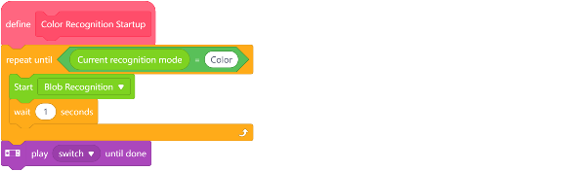

Task 2: Obtain color block data and create control variables
Step 2: Create variables and main loop structure. Establish key variables such as color block coordinates, width, speed, and differential speed.  Color_X: Stores the X-coordinate of the center of the recognized color block.  Color_W: Stores the width of the recognized color block (used to determine distance).  Speed: Stores the robot's base forward/backward speed.  Dspeed: Stores the speed difference between the left and right wheels for steering control.  last_seen_time: Stores the last time a color block was detected (used for timeout judgment).  time_out: Stores a timeout threshold (e.g., 0.5 seconds).  Step 3: Implement core control logic.Achieve intelligent tracking and timeout stop functionality by validating color block effectiveness, calculating motion speed, and determining steering differential speed. | 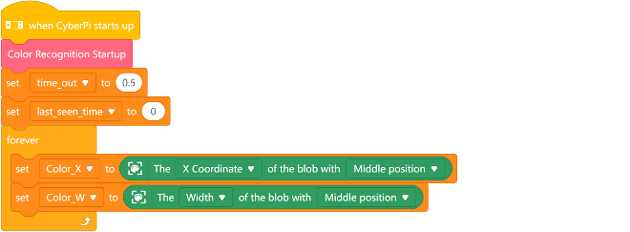  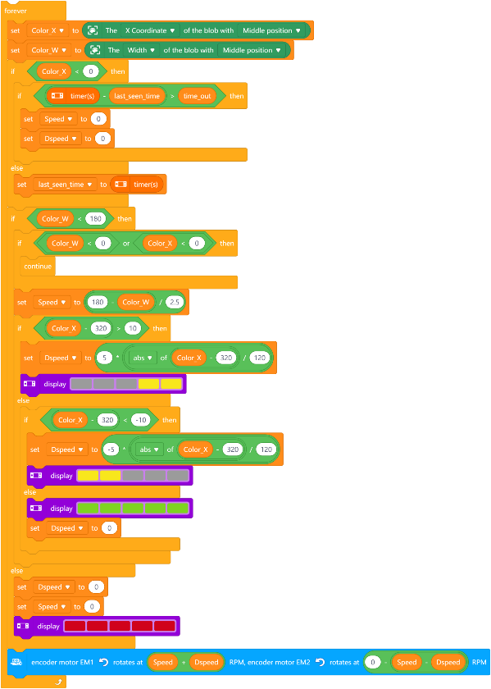

Section 4 - Presentation
In this session, students are invited to present and compare their group project outcomes. After 2-3 groups have presented, the teacher will guide a whole-class discussion. Please observe carefully: What are the similarities and differences in the solutions developed by each group? What is the most ingenious part of their designs? And explore the potential applications of color recognition technology in broader scenarios, such as intelligent sorting and environmental interaction.

Section 5 - Evaluate
Now let's review some key points in this lesson.
- What was the biggest challenge you faced in today's project? How did you and your team work together to solve it?
- Beyond target tracking, what other potential applications could color recognition technology have?
- How can color recognition functionality be applied to enhance daily life or industrial production?

